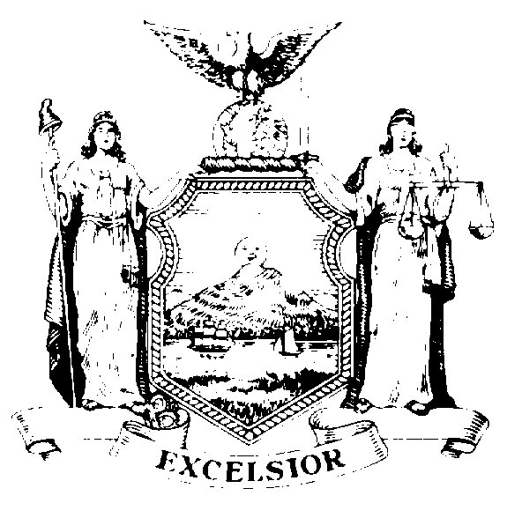
Public Information Office
Robin Marilla
Records Access Officer

THE ASSEMBLY
STATE OF NEW YORK
ALBANY

Room 202
Legislative Office Building
Albany, New York 12248
(518) 455-4218

Wednesday, January 22, 2014

Dear Elena Sassower:

We are in the process of reviewing our records, as they relate to your requests. We will formally respond to your requests tomorrow.

Sincerely,
Robin Marilla

