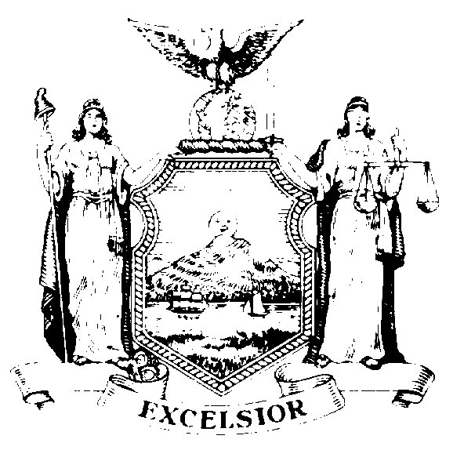
Public Information Office
Robin Marilla
Records Access Officer

THE ASSEMBLY
STATE OF NEW YORK
ALBANY

Room 202
Legislative Office Building
Albany, New York 12248
(518) 455-4218

March 18, 2014

Dear Elena Sassower:

Your FOIL request dated March 11, 2014 was received on that date. You have requested all publicly accessible documents pertaining to the retention of the law firms Kirkland & Ellis, LLP; Kasowitz, Benson, Torres & Friedman, LLP; and Loeb & Loeb, LLP and any other law firms or attorneys for purposes of legal representation subsequent to those documents provided in response to your FOIL request of December 16, 2013. At that time, the New York State Assembly provided you with the Justification for Contract between the New York State Assembly and Kasowitz, Benson, Torres & Friedman, LLP.

Enclosed please find a letter amendment to the contract previously provided to you, which is the only subsequent document responsive to your request.

Additionally, as was true at the time of the Assembly’s prior response, there are no resolutions passed by the Assembly and Senate with respect thereto.

Sincerely,
Robin Marilla

