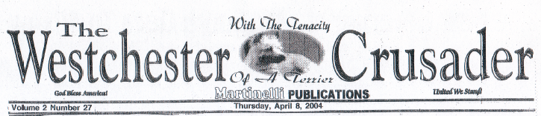

Reprinted with Publisher’s permission

LETTER TO THE EDITOR …

Your 3/25/03 Westchester Crusader article is right in opining that the judicial nominating process is corrupt. This is borne out by more than a decade of empiric research by the Center for Judicial Accountability, Inc. and front-line, in-the-trenches experience, now publicly accessible on our judgewatch.org website. But you are dead-wrong in advocating for Administrative Judge Nicolai’s perpetuation in his Supreme Court office now that his 14-year term is coming to an end.

There are two overriding reasons why you should reconsider your latter position. One, because Judge Nicolai’s on-the-job performance, administrative as well as adjudicative, is not only deficient, but dangerous. In cases where I have direct personal knowledge, he has shown time and again his disrespect for the rule of law, as well as for the Code of Judicial Conduct. Most egregious was his failure and refusal to recuse himself or to grant a change in venue in matters where I was a party litigant, notwithstanding in 1990, I sued Judge Nicolai as a party respondent in Castracan and Bonelli v. Francis Nicolai, et al., the Election Law case wherein, as pro bono counsel to the petitioners, I challenged the Three-Year Deal that propelled Judge Nicolai to the Supreme Court bench. (See our website judgewatch.org to access my filed papers in that case). Even apart from his actual bias, at very least, recusal was mandated because of his obvious self-interest and because "his impartiality might reasonably be questioned," a disqualification under Canon3C.(1) of the Code.
Two, because Judge Nicolai gained his Supreme Court position as a principal in, and accomplice to, one of the most corrupt judicial cross-endorsement deals, of a nature and on a scale unprecedented, in the annals of political deal-making: the infamous 1989 Three-Year Deal between Republican and Democratic party leaders in the five counties comprising the Ninth Judicial District of New York, which includes Westchester. Traded as if they were playing cards were seven (7) judgeships, including the patronage-rich Westchester Surrogate judgeship, which, otherwise would likely have fallen to the Democrats, who by then outnumbered Republicans in this County.

Thanks to that fraud perpetrated on a thus disenfranchised electorate, Judge Nicolai, with county court judicial experience handling only criminal cases, came straight to Supreme Court, a court of general civil jurisdiction, by guaranteed nomination and election to that position, along with six other judges who, as parties and beneficiaries were, likewise, freed from competing for their judicial positions on merit, instead rewarded with judgeships as political paybacks based on their ties with their party leaders and their acceptance of the Deal’s illegal and unethical terms and conditions, including a pledge of payback patronage, when elected. These patent infringements of judicial independence were actually laid out in an incontrovertible written document, captured for all posterity on our website.
The bitter harvest of corrupt and biased decisions issued over the past 14 years by Judge Nicolai and other Three-Year Deal judicial colleagues, who committed a gross assault on our democratic electoral process in the dishonest way in which they gained their judicial offices, has not only obstructed the true administration of justice, but has wrongfully cost our taxpaying public millions of dollars, not to mention the incalculable suffering and loss to our citizenry of their legal rights and their irreparably shattered lives.
Doris L. Sassower, Co-Founder and Director
Center for Judicial Accountability, Inc.
http://www.judgewatch.org

